VISVESVARAYA TECHNOLOGICAL UNIVERSITY
JNANASANGAMA, BELAGAVI - 590018
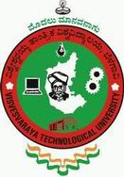

Project Phase I Report
on
Auto UI Code Generation Using AI

Submitted in partial fulfillment of the requirement
for the award of the degree of

Bachelor of Engineering
in

Computer Science & Engineering
by

Manu K J (1BG16CS059)
Murudeshwar Barole (1BG16CS062)
Nihaarika A Jagadish (1BG16CS067)
Sreenidhi KR (1BG16CS103)

Under the Guidance of

Ms. Harshitha K
Asst. Prof., Dept of CSE
BNMIT

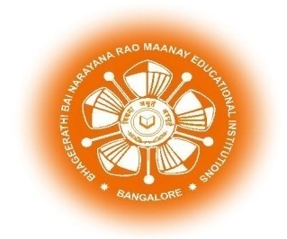
Vidyaya Amrutham Ashnuthe

B.N.M. Institute of Technology
Approved by AICTE, Affiliated to VTU, Accredited as grade A Institution by NAAC.
All UG branches – CSE, ECE, EEE, ISE & Mech.E accredited by NBA for academic years 2018-19 to
2020-21 & valid upto 30.06.2021
Post box no. 7087, 27th cross, 12th Main, Banashankari 2nd Stage, Bengaluru- 560070, INDIA
Ph: 91-80- 26711780/81/82 Email: principal@bnmit.in, www. bnmit.org

Department of Computer Science and Engineering
2019-2020

B.N.M. Institute of Technology
Approved by AICTE, Affiliated to VTU, Accredited as grade A Institution by NAAC.
All UG branches – CSE, ECE, EEE, ISE & Mech.E accredited by NBA for academic years 2018-19 to 2020-21
& valid upto 30.06.2021
Post box no. 7087, 27th cross, 12th Main, Banashankari 2nd Stage, Bengaluru- 560070, INDIA
Ph: 91-80- 26711780/81/82 Email: principal@bnmit.in, www. bnmit.org

DEPARTMENT OF COMPUTER SCIENCE AND ENGINEERING

Vidyaya Amrutham Ashnuthe

CERTIFICATE

Certified that the project phase I entitled Auto UI code Generation Using AI carried out by Mr. Manu K J (1BG16CS059), Mr. Murudeshwar Barole (1BG16CS062), Ms. Nihaarika A Jagadish (1BG16CS067) and Mr. Sreenidhi K R(1BG16CS103) the bonafide students of B.N.M Institute of Technology in partial fulfillment for the award of Bachelor of Engineering in Computer Science & Engineering of the Visvesvaraya Technological University, Belagavi during the year 2019-2020. It is certified that all corrections / suggestions indicated for Internal Assessment have been incorporated in the report deposited in the departmental library. The project phase I report has been approved as it satisfies the academic requirements in respect of Project work prescribed for the said Degree.

Ms. Harshitha K Dr. Sahana D. Gowda Dr. Krishnamurthy G N

Assistant Professor Professor and HOD Principal,

Department of CSE Department of CSE BNMIT, Bengaluru

BNMIT, Bengaluru BNMIT, Bengaluru

